Activity 6:

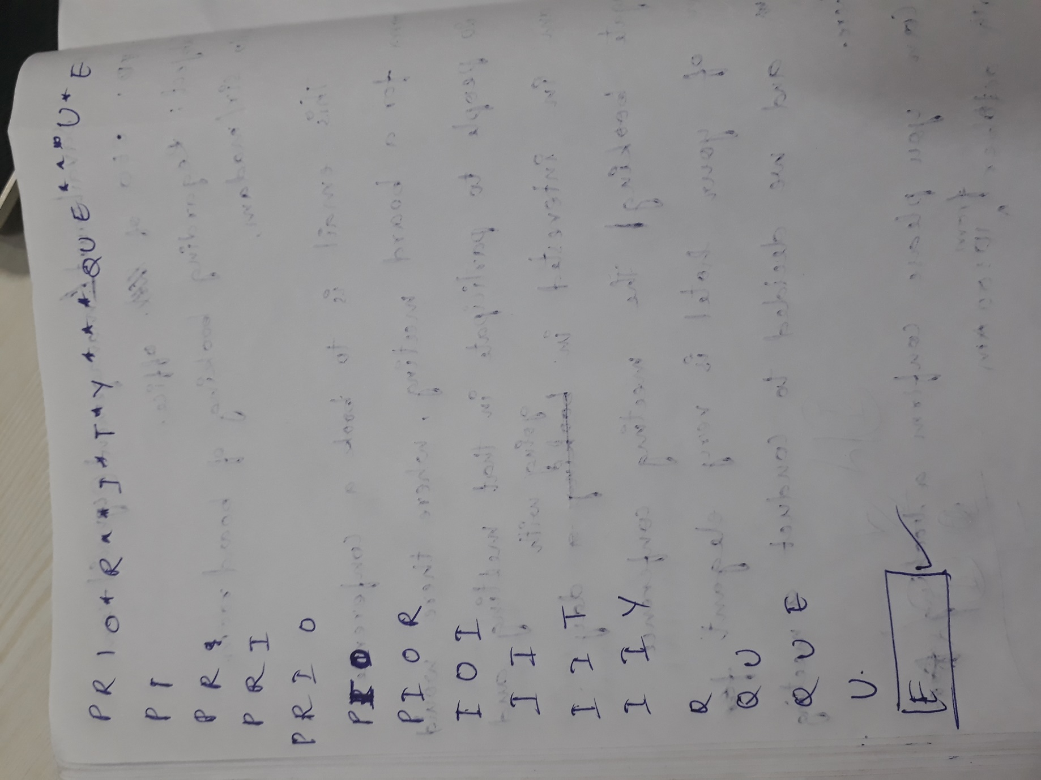

Activity 7:

No, an array that is sorted in Ascending order is not a min-oriented heap. Because in min heap the only condition is that the child must be greater than the parent node where as sorted array should be in an order.